量子醫學的理論
- 自然秩序與量子生物學
量子論─德國物理學家，馬克斯蒲朗克(Max Planck )研究十九世紀懸而未決的一個問題─熱輻射能以不連續性在不同波長上的分佈，他稱這是這輻射能是以分立束為量子(quantum)的假設，1905年愛因斯坦(Einstein)， 提出光電效應(photoelectric effect), 解釋光能量置換電子的現象，1913年玻耳(Niels Bohr)提出: 原子中的電子處於一些固定的能量階(energy level)，當電子在能階間躍遷時，電磁能以分立的能量束(quantum)釋放或吸收，爾後量子力學的一致性詮釋─即著明的哥本哈根詮釋(Copenhagen interpretation)，以玻耳在丹麥建立的物理研究所命名
量子力學─1920年中， 海森堡(Werner Heisenberg)和薛丁格(Erwin Schroginger)，提出量子力學新體系，以解釋電子及所有次原子(subatomic)的波粒二象性，因為由牛頓的傳統力學定律及馬克斯威爾的電磁理論，在微觀世界中完全失效
§ 量子物理學關於巨觀與微觀、整體與部份之間的關係, 傳統的西方觀念被徹底改變，而與東方的神秘主義哲學思想概念相似，包括印度教、佛教、道教等思想
費布納西數列─Fibonacci series 十三世紀數學家費布納西發明的一種無窮數列，第一, 二, 項皆等於1，以後每項等於前面兩項之和. 即:1 1 2 3 5 8 13 21 34 55 89…..此數列與許多數學結構及自然現象有密切關係.
例如: 百合花3瓣, 毛茛有5瓣, 許多飛燕草屬都是8瓣, 萬壽菊13瓣, 紫莞有21瓣, 大多數雛菊都是34, 55, 89瓣. 大型的向日葵, 頂上的小花( floret, 最後會變成種子的微型花朵),排列成兩組螺線, 一組順時針旋轉, 另一組反時針旋轉,其組合通常都是一組34, 另一組55. 或55與89, 或89與144…
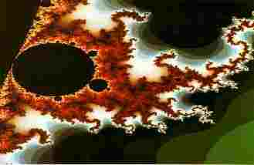
Benoit Mandelbrot, the inventor of fractal geometry, using simple iterative equations to explore the behavior of numbers on the complex plane.
§ 混沌─chaos 看似雜亂無章的行為, 毫無秩序可言, 卻可以「微分」方程式做出完整描述的系統, 即隱含的秩序(the enfolderorder)
§ 量子不確定性─quantum indeterminacy 即海森堡( Werner Heisenberg, 1901-1976) 提出的測不準原理( uncertainty principle)，認為某些成對的物理量不可能同時測得極準確( 真相)，其中一個測得愈準，另一個就愈不精確; 以其學說所建立的力學體系，即稱做「量子力學」quantum mechanics, 討論次原子系統的動力學的量子理論
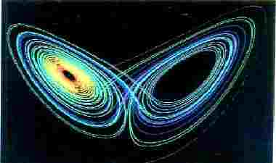
In 1960s, chaologists- Edward Lorenz discovered that very small differences in the initial daily weather data that he input into his model would make a very large difference in a long-range forecast.
Strange attractors like this one depict a system whose behavior never repeats itself and is always unpredictable and yet, paradoxically, always resembles itself and is infinitely recognizable
§ 碎形幾何─fractal 亦稱「分維」，由數學家曼德布洛特( Benoit Mandelbrot, 1924-)提出，其維度並非整數的幾何圖形，其圖形在愈來愈細微的尺度上不斷自我重複, 是一項研究不規則性的科學; 許多自然界的形體及人體的構造，皆以此「模式」( pattern )模擬複製，造成碎形的動力過程稱做「混沌現象」

§ 蝴蝶效應─butterfly effect 在混沌系統中, 極小的擾動就會產生極大的影響
§ 量子定律─包利互斥原理Pauli exclusion principle, 認為沒有兩個費密子可以有同樣的量子狀態
§ 蒲朗克常數─Planck’s constant 基本的作用量子或光子能量與其頻率之比
§ 量子勢─量子系統描述模式, 認為量子行為的飄忽不定及無法預測的起伏性, 是一種類似引力場的「勢」場
§ 相對論─Theory of relativity於1905年由愛因斯坦提出狹義相對論，即E=mc² 引入時間澎脹以及質量、能量之間的等價關係，此一不尋常的概念, 認為沒有任何物體或物理感應能夠超越光速，1915年提出廣義相對論， 提出引力對時空結構產生的效應
§ 薛丁格貓詭論─Schrodinger's cat paradox是一個詮釋量子不確定性的思想實驗，人們只能用量子過程使一隻貓, 處於「活貓」與「死貓」兩態壘加的狀態之中，而無法觀測到貓的結果究竟是「死貓」或「活貓」
§ 波函數─描述量子系統態的數學, 其函數行為以Schrodinger's equation 薛丁格方程式來描述
§ 量子跳躍─quantum leap 次原子粒子( subatomic particle)在某處消失, 而同時在另一處出現
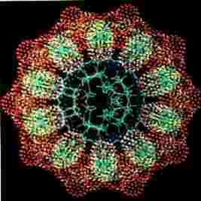
§ 量子觀測角色─quantum observership 從量子理論抽取某種資訊，意味著也決定了系統其他部份的表現, 即使這兩個部份的距離可能非常遠( 如1 光年)，使得以光速行進的訊號都無法及時傳遞改變的訊息, 以資觀測. 哥本哈根學派的解釋認為，系統只有在被觀測到的時候才決定了的. 波姆的解釋則認為，系統是決定論式的，訊息是以非區域性的方式傳遞的. 多重世界的解釋認為, 這兩種狀態都存在, 在觀測的時候, 宇宙都會分裂成兩個部份.
The forces of symmetry and chaos embodied in the DNA molecule both drive life forward and contain it within limits. This is computer simulation of the spiraling DNA ladder as seen from the top.

二. 生物自然反應的原則
達爾文(英國人Charles Darwin, 1809-1882)─1859年發表「 On the origin of Species by means of Natural Selection, or the preservation of favoured races in the struggle for life」 , 「 透過天擇或是奮鬥求生過程中保存有利種族的方式, 造成的物種源始」 , 即「 物種原始」
Dr. Hand Selys: Adaption is a basic principle of biology.
What is organism’s reactivity ? Antigenless electro magnetic reactivity in patients :
Two purposes of electro static magnetic reactivity:
1. To move towards – Sense nutrients, mates, pleasant fields
2. To move away from – Sense toxins, danger, disturbing fields
In simpler terms : the body must be able to move to sense and move towards things that it wants, it needs, and its likes, and move away from the items that could impose danger or threats to life. Such items might be toxins, allergens, poisons and harsh fluxes in the environment.
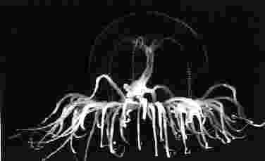
The primordial shape of the jellyfish is a sinuous record of the dynamical forces of the flowing water in which the creature evolved.
The basic scientific premise is that nature has many subtle differences that synthetic chemicals do not. There is a measurable and dramatic difference in safety, with natural homeopathic medication having far less side effects. Only nature knows.
Electrical reactivity is something that all life, even one-cell organisms, must have in order to interact with their environment. We know absolutely that all organisms have an electromagnetic field around them, which has a magnetic, capacitance and conductance nature. When something negates this field, life may be destroyed. Thus the electrical energy field around the body of any organism is part of its ability to interact with the environment.
The quantum coherency effect is achieved by matching the virtual photon and voltammetric signature pattern of a reactive substance in the body of the patient and then watching the voltammetric resistance changes that happen in the patient in response to the item. If there is a coherency, a reactive positive or negative pattern can be induced. This is the field of reactivity so that it can move towards nutrition and away from toxins and danger. This is measured in a voltammetry.
Any of the reactions in the body involve oxidation and reduction, which are defined by their volt and ammeter changes. These ionic changes in the body happen within one hundredth of second, because the relaxation of ionic changes is approximately one hundredth of a second. DNA is found to have subspace reception effects by rein. This allows DNA to effect electron and photon transfer through the piezo electric effect.

The branching of our lungs, nerves, and circulatory systems is evidence that our very bodies are a product of feedback. The fractal geometry of the circulatory system allows delivery of blood to every cell in the body.
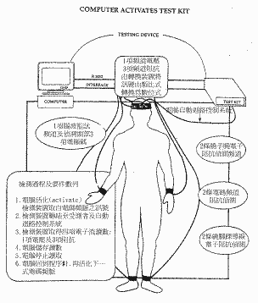
The Xrroid takes in scores of capacitance, inductance, resistance, voltage, amperage, etc., and converts them into an electrical reactivity score on thousands of items.

三. ACCURACY OF XRROID REACTIVITY

 | BACTERIAL INFECTIONS | POSITIVE REACTIVITY
Hemolytic Strep | 10 | 10
E.Coli | 12 | 9
Staph | 14 | 12
Proteus | 3 | 2
 | 39 Tested | 33 Reacted
Accuracy Ratio: 87 %

 | FUNGAL INFECTIONS | POSITIVE REACTIVITY
Candida Albicans | 30 | 28
Tinea | 22 | 20
 | 52 Tested | 48 Reacted
Accuracy Ratio: 94 %

 | SARCODAL DISTURBANCES | POSITIVE REACTIVITY
Liver Disturbance | 12 | 10
Adrenal Deficiency | 20 | 18
Kidney Patients | 16 | 12
Thyroid Patients | 23 | 19
 | 71 Tested | 59 Reacted
Accuracy Ratio: 83 %

 | ISODES POSITIVE | REACTIVITY
Cholesterol | 19 | 15
Lactose Intolerance | 12 | 19
Toxic Water | 86 | 80
 | 117 Tested | 104 Reacted
Accuracy Ratio: 89 %
Upper Data taken from the Lowermoor study

四. Trivector System 三向量的觀念
1. 任何形狀的物體都可以長度、寬度、深度三向量的相關性來形容.
2. 任何液體也可看成是液態晶體, 透過多晶型的分析(polymophous analysis), 亦可由 三向量來描述其特性.
3. 任何有機體都是帶電體, 人本身亦是帶電體, 人對電磁場都具有磁場反應( reactivefield ), 任何組織器官皆有磁場反應, 此反應可以透過電壓( voltage )、電流強度(amperage)、電阻(resistance)的三度向量改變, 來測量人體對營養素及毒素的反應.
§ 各種動物都具有磁場反應: 例如:
1. 把一塊磁鐵放在鴿子頭上, 鴿子就找不到回家的路.
2. 牡礪放在密封箱中, 牡礪仍隨著月亮的出現而一開一合.
3. 鯊魚的磁場感應功能能尋找10哩外的獵物.
4. 狗的思維磁場, 有時可以感應遙距的主人
5. 澎湖望安島出生的綠蠵龜，在世界海洋中飄流，一定又回到望安島產卵.
6. 很多動物能感測即將發生的地震現象
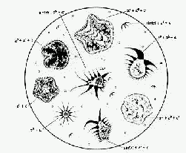
By using the iterative features of “recursive programing,” Chaologists--Dawkins has even created a “biomorph” program that simulates evolution. The program iterates genes and occasionally adds copying errors which are blown up by feedback into new generations of computer creatures, some of which resemble the trilobitees that swam in the oveans of the Cambrian era 570 million years ago.
Pickover’s biomorphs show a self-similarity at different scales and illustrate a significant feature of feedback in dynamical systems. Real systems, such as human beings and mountain ranges, also show self-similarity at different scales

